Note: I have created 2 folders in main “Course2_Assignment_MartandKulkarni”, “property-registration” and “property-registration_Local”.

* property-registration: Folder you provided with provided network settings where I added my chaincode folder.
* property-registration_Local: As I had network setup on my MAC localhost, I have made changes to network configuration to have it working. Hence this folder contains all the changes to network folder with my chaincode that worked in my localhost OS
* Alignment of code with indentation is properly formatted and same is visible in VS editor.
* I have included both doc and pdf versions

The command to bootstrap the network,

Command : sh fabricNetwork.sh up

Screenshots:

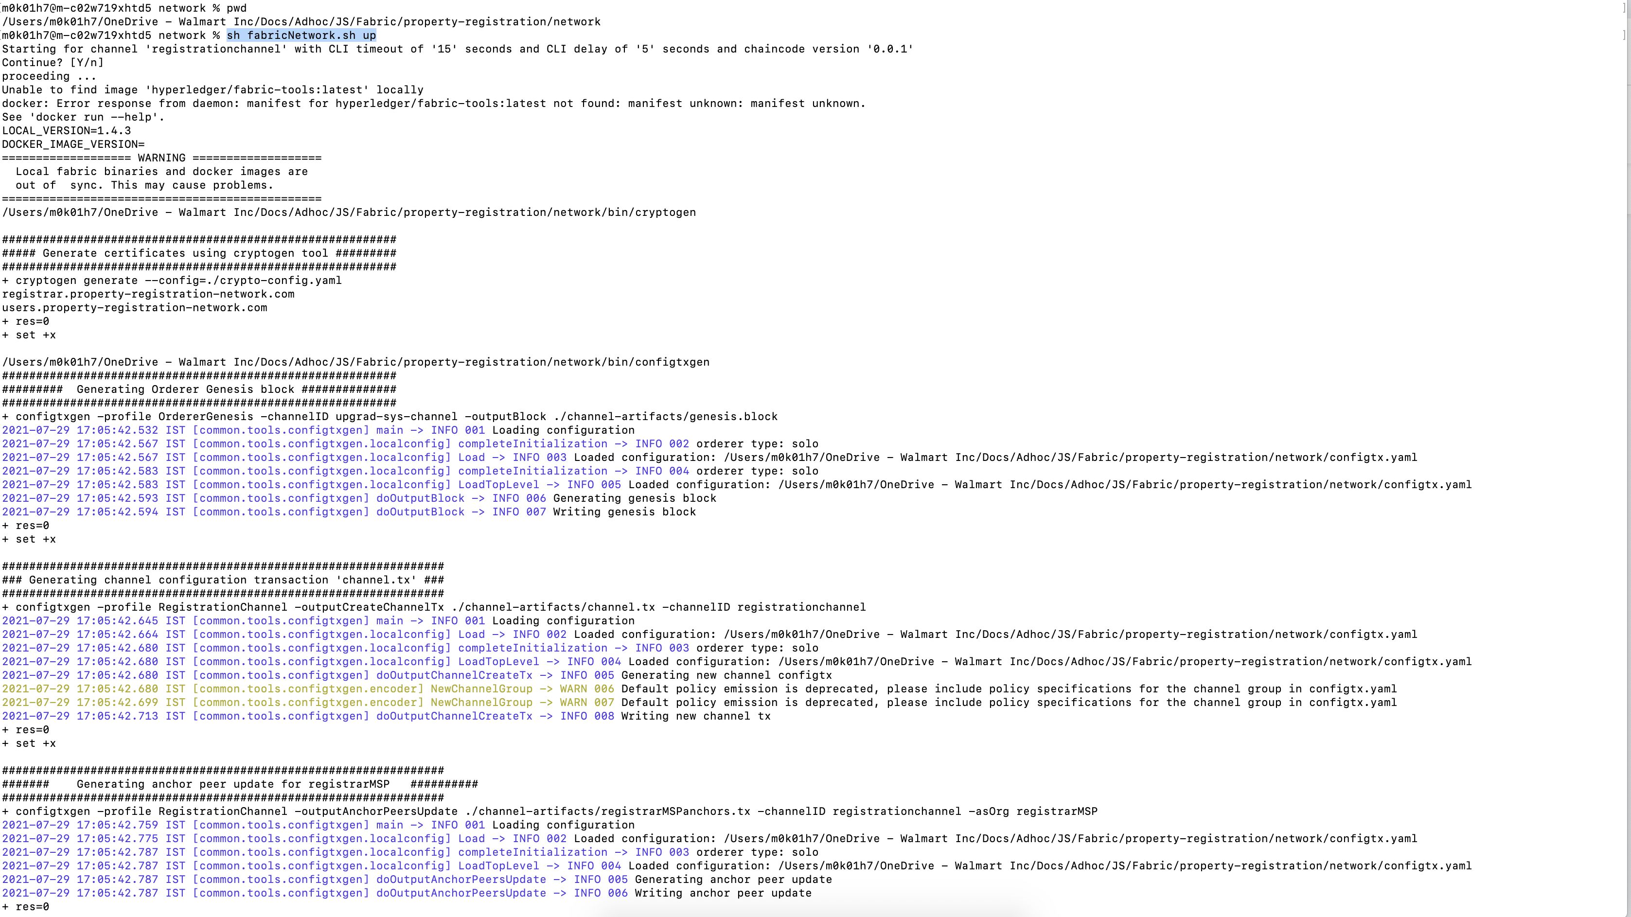

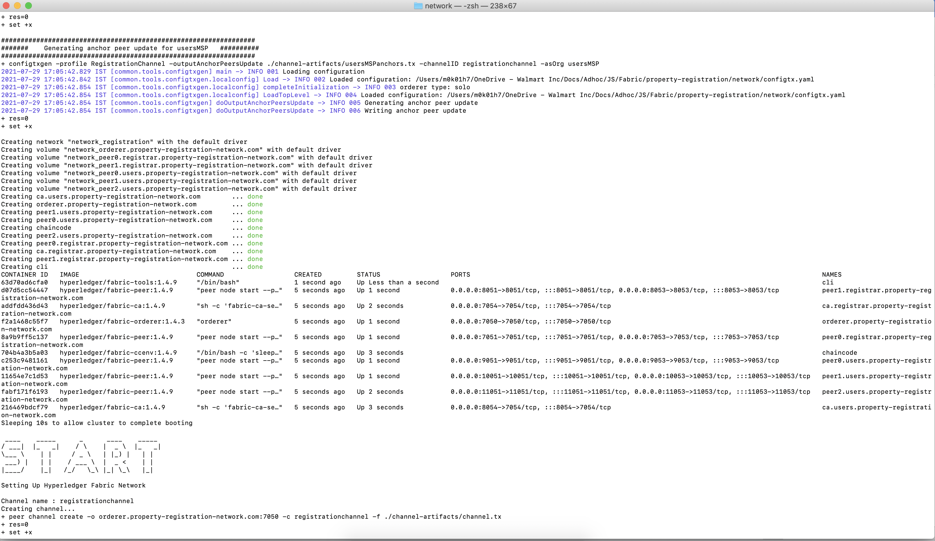

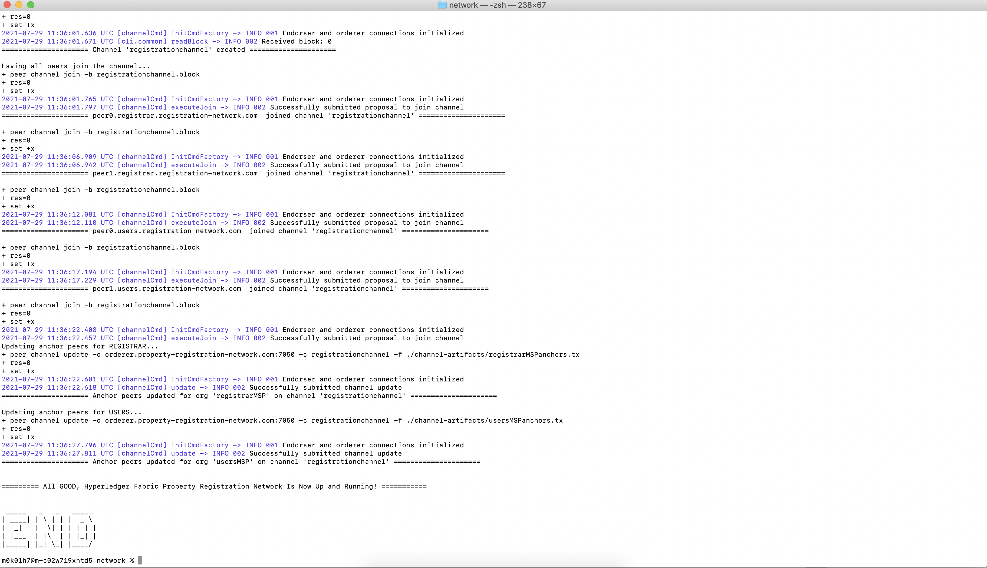

The command to install and instantiate the chaincode,

Command: sh fabricNetwork.sh install

Screenshot:

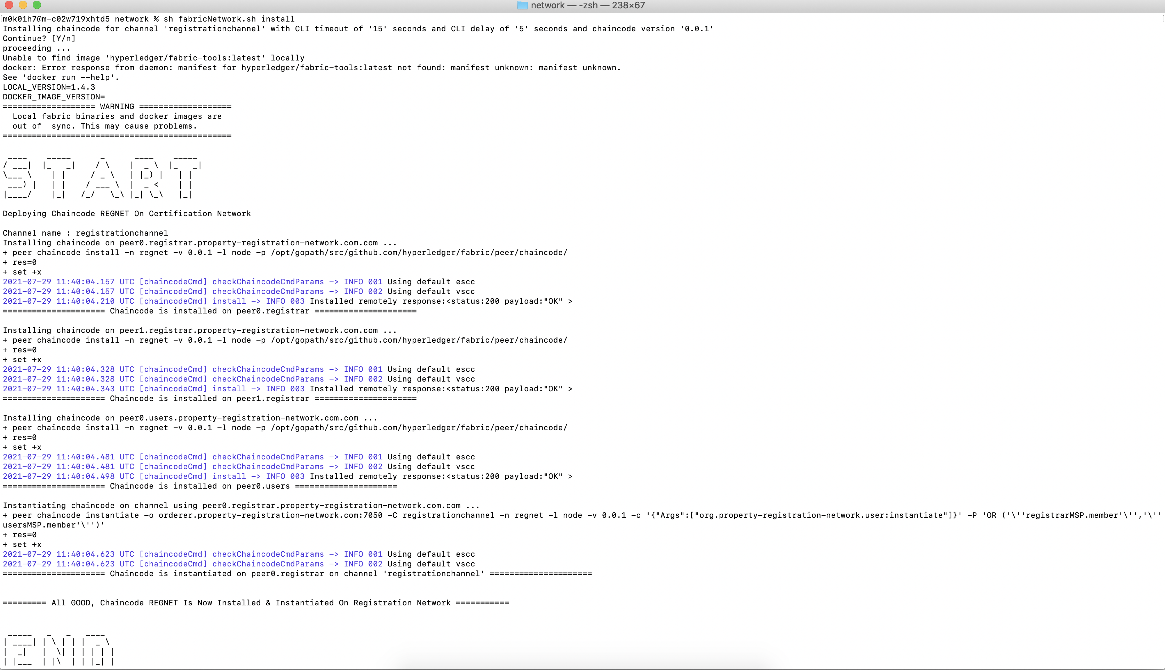

Following is the workflow + screenshot that I ran to test chaincode sequentially. Users being created are “Buyer” and “Seller”,

Method: requestNewUser

Test Case 1: To successfully create User “Buyer” request

Command: peer chaincode invoke -o orderer.property-registration-network.com:7050 -C registrationchannel -n regnet -c '{"Args":["org.property-registration-network.user:requestNewUser","Buyer","abc@email.com","9898989898","aadharNumber1"]}'

Result: 2021-07-29 11:59:29.372 UTC [chaincodeCmd] chaincodeInvokeOrQuery -> INFO 001 Chaincode invoke successful. result: status:200 payload:"{\"name\":\"Buyer\",\"email\":\"abc@email.com\",\"phoneNumber\":\"9898989898\",\"aadharNumber\":\"aadharNumber1\",\"createdAt\":\"2021-07-29T11:59:29.366Z\",\"updatedAt\":\"2021-07-29T11:59:29.366Z\"}"

Screenshot:



Test Case 2: To Successfully create user “Seller” request

Command: peer chaincode invoke -o orderer.property-registration-network.com:7050 -C registrationchannel -n regnet -c '{"Args":["org.property-registration-network.user:requestNewUser","Seller","xyz@email.com","0000000000","aadharNumber2"]}'

Result: 2021-07-29 12:42:59.486 UTC [chaincodeCmd] chaincodeInvokeOrQuery -> INFO 001 Chaincode invoke successful. result: status:200 payload:"{\"name\":\"Seller\",\"email\":\"xyz@email.com\",\"phoneNumber\":\"0000000000\",\"aadharNumber\":\"aadharNumber2\",\"createdAt\":\"2021-07-29T12:42:59.481Z\",\"updatedAt\":\"2021-07-29T12:42:59.481Z\"}"

Screenshot:



Test Case 3: Try requesting to create same “Buyer” user again

Command: peer chaincode invoke -o orderer.property-registration-network.com:7050 -C registrationchannel -n regnet -c '{"Args":["org.property-registration-network.user:requestNewUser","Buyer","abc@email.com","9898989898","aadharNumber1"]}'

Result: Error: endorsement failure during invoke. response: status:500 message:"transaction returned with failure: Error: User with name : Buyer and with aadhar : aadharNumber1 is already present"

Screenshot:



Method: approveNewUser

Test Case 1: Since Buyer is not yet approved by registrar, viewUser function for “Buyer” should return “Not Found”

Command: peer chaincode invoke -o orderer.property-registration-network.com:7050 -C registrationchannel -n regnet -c '{"Args":["org.property-registration-network.user:viewUser","Buyer","aadharNumber1"]}'

Result: Error: endorsement failure during invoke. response: status:500 message:"transaction returned with failure: Error: User : Buyer with aadhar number : aadharNumber1 not found"

Screenshot:



Test Case 2: Check if user request is present before approving. For this negative testing, I will test with username: Martand (for which I haven’t raised request)

Command: peer chaincode invoke -o orderer.property-registration-network.com:7050 -C registrationchannel -n regnet -c '{"Args":["org.property-registration-network.registrar:approveNewUser","Martand", "aadharNumber1"]}'

Result: Error: endorsement failure during invoke. response: status:500 message:"transaction returned with failure: Error: User request with name : Martand and aadhar number : aadharNumber1 for approval is not found as in network"

Screenshot:



Test Case 3: Registrar to approve “Buyer” user and add new field to user object upgradCoins = 0

Command: peer chaincode invoke -o orderer.property-registration-network.com:7050 -C registrationchannel -n regnet -c '{"Args":["org.property-registration-network.registrar:approveNewUser","Buyer", "aadharNumber1"]}'

Result: 2021-07-29 12:56:48.340 UTC [chaincodeCmd] chaincodeInvokeOrQuery -> INFO 001 Chaincode invoke successful. result: status:200 payload:"{\"name\":\"Buyer\",\"email\":\"abc@email.com\",\"phoneNumber\":\"9898989898\",\"aadharNumber\":\"aadharNumber1\",\"createdAt\":\"2021-07-29T12:42:20.016Z\",\"updatedAt\":\"2021-07-29T12:56:48.336Z\",\"upgradCoins\":0}"

Screenshot:



Test Case 4: Registrar to approve “Seller” user and add new field to user object upgradCoins = 0

Command: peer chaincode invoke -o orderer.property-registration-network.com:7050 -C registrationchannel -n regnet -c '{"Args":["org.property-registration-network.registrar:approveNewUser","Seller", "aadharNumber2"]}'

Result: 2021-07-29 12:59:39.689 UTC [chaincodeCmd] chaincodeInvokeOrQuery -> INFO 001 Chaincode invoke successful. result: status:200 payload:"{\"name\":\"Seller\",\"email\":\"xyz@email.com\",\"phoneNumber\":\"0000000000\",\"aadharNumber\":\"aadharNumber2\",\"createdAt\":\"2021-07-29T12:42:59.481Z\",\"updatedAt\":\"2021-07-29T12:59:39.684Z\",\"upgradCoins\":0}"

Screenshot:



Method: viewUser (from both user and registrar SC)

Test Case 1: view buyer

Command: peer chaincode invoke -o orderer.property-registration-network.com:7050 -C registrationchannel -n regnet -c '{"Args":["org.property-registration-network.user:viewUser","Buyer","aadharNumber1"]}'

Result: 2021-07-29 13:03:57.426 UTC [chaincodeCmd] chaincodeInvokeOrQuery -> INFO 001 Chaincode invoke successful. result: status:200 payload:"{\"name\":\"Buyer\",\"email\":\"abc@email.com\",\"phoneNumber\":\"9898989898\",\"aadharNumber\":\"aadharNumber1\",\"createdAt\":\"2021-07-29T12:42:20.016Z\",\"updatedAt\":\"2021-07-29T12:56:48.336Z\",\"upgradCoins\":0}"

Screenshot:



Test Case 2: view seller

Command: peer chaincode invoke -o orderer.property-registration-network.com:7050 -C registrationchannel -n regnet -c '{"Args":["org.property-registration-network.user:viewUser","Seller","aadharNumber2"]}'

Result: 2021-07-29 13:04:54.112 UTC [chaincodeCmd] chaincodeInvokeOrQuery -> INFO 001 Chaincode invoke successful. result: status:200 payload:"{\"name\":\"Seller\",\"email\":\"xyz@email.com\",\"phoneNumber\":\"0000000000\",\"aadharNumber\":\"aadharNumber2\",\"createdAt\":\"2021-07-29T12:42:59.481Z\",\"updatedAt\":\"2021-07-29T12:59:39.684Z\",\"upgradCoins\":0}"

Screenshot:



Test Case 3: view seller with wrong aadhar number (basically suggesting invalid user scenario)

Command: peer chaincode invoke -o orderer.property-registration-network.com:7050 -C registrationchannel -n regnet -c '{"Args":["org.property-registration-network.user:viewUser","Seller","aadharNumber3"]}'

Result: Error: endorsement failure during invoke. response: status:500 message:"transaction returned with failure: Error: User : Seller with aadhar number : aadharNumber3 not found"

Screenshot:



Test Case 4: view Buyer from registrar SC

Command: peer chaincode invoke -o orderer.property-registration-network.com:7050 -C registrationchannel -n regnet -c '{"Args":["org.property-registration-network.registrar:viewUser","Buyer", "aadharNumber1"]}'

Result: 2021-07-29 13:10:05.648 UTC [chaincodeCmd] chaincodeInvokeOrQuery -> INFO 001 Chaincode invoke successful. result: status:200 payload:"{\"name\":\"Buyer\",\"email\":\"abc@email.com\",\"phoneNumber\":\"9898989898\",\"aadharNumber\":\"aadharNumber1\",\"createdAt\":\"2021-07-29T12:42:20.016Z\",\"updatedAt\":\"2021-07-29T12:56:48.336Z\",\"upgradCoins\":0}"

Screenshot:



Method: rechargeAccount

Test Case 1: Invalid bank transaction ID sent for Buyer account. Only upg100, upg500, upg1000 are accepted

Command: peer chaincode invoke -o orderer.property-registration-network.com:7050 -C registrationchannel -n regnet -c '{"Args":["org.property-registration-network.user:rechargeAccount","Buyer","aadharNumber1","upg200"]}'

Result: Error: endorsement failure during invoke. response: status:500 message:"transaction returned with failure: Error: Invalid Bank Transaction ID : upg200"

Screenshot:



Test Case 2: User not in network

Command: peer chaincode invoke -o orderer.property-registration-network.com:7050 -C registrationchannel -n regnet -c '{"Args":["org.property-registration-network.user:rechargeAccount","Martand","aadharNumber1","upg100"]}'

Result: Error: endorsement failure during invoke. response: status:500 message:"transaction returned with failure: Error: User : Martand with aadhar number : aadharNumber1 not found"

Screenshot:



Test Case 3: Recharge Buyer’s account with 100 upgradCoins

Command: peer chaincode invoke -o orderer.property-registration-network.com:7050 -C registrationchannel -n regnet -c '{"Args":["org.property-registration-network.user:rechargeAccount","Buyer","aadharNumber1","upg100"]}'

Result: 2021-07-29 13:18:05.151 UTC [chaincodeCmd] chaincodeInvokeOrQuery -> INFO 001 Chaincode invoke successful. result: status:200 payload:"{\"name\":\"Buyer\",\"email\":\"abc@email.com\",\"phoneNumber\":\"9898989898\",\"aadharNumber\":\"aadharNumber1\",\"createdAt\":\"2021-07-29T12:42:20.016Z\",\"updatedAt\":\"2021-07-29T13:18:05.148Z\",\"upgradCoins\":100}"

Screenshot:



Method: propertyRegistrationRequest

Test Case 1: Check if owner is in network. To carry out this negative test case, I will check if user “Martand” who is not in network is unable to register his property

Command: peer chaincode invoke -o orderer.property-registration-network.com:7050 -C registrationchannel -n regnet -c '{"Args":["org.property-registration-network.user:propertyRegistrationRequest","Martand","abcd","1234","100"]}'

Result: Error: endorsement failure during invoke. response: status:500 message:"transaction returned with failure: Error: Owner : Martand with aadhar number : abcd not found in network"

Screenshot:



Test Case 2: Successfully Register property with propertyID : 1234 by Seller and price :100 upgradCoins, status : “registered” and owner : seller + aadharNumber (composite key)

Command: peer chaincode invoke -o orderer.property-registration-network.com:7050 -C registrationchannel -n regnet -c '{"Args":["org.property-registration-network.user:propertyRegistrationRequest","Seller","aadharNumber2","1234","100"]}'

Result: 2021-07-29 13:41:44.872 UTC [chaincodeCmd] chaincodeInvokeOrQuery -> INFO 001 Chaincode invoke successful. result: status:200 payload:"{\"name\":\"Seller\",\"aadharNumber\":\"aadharNumber2\",\"propertyID\":\"1234\",\"price\":\"100\",\"owner\":\"\\u0000org.property-registration-network.user\\u0000Seller-aadharNumber2\\u0000\",\"status\":\"registered\"}"

Screenshot:



Test Case 3: viewProperty for propertyID: 1234. Since property is not yet approved, this method should “Not Found”

Command: peer chaincode invoke -o orderer.property-registration-network.com:7050 -C registrationchannel -n regnet -c '{"Args":["org.property-registration-network.user:viewProperty","1234"]}'

Result: Error: endorsement failure during invoke. response: status:500 message:"transaction returned with failure: Error: Property with ID 1234 is not found for provided propertyID"

Screenshot:



Method: approvePropertyRegistration by registrar

Test Case 1: Check if property is requested for registration by wrong ID: 12345

Command: peer chaincode invoke -o orderer.property-registration-network.com:7050 -C registrationchannel -n regnet -c '{"Args":["org.property-registration-network.registrar:approvePropertyRegistration","1234"]}'

Result: Error: endorsement failure during invoke. response: status:500 message:"transaction returned with failure: Error: Request for Property with ID : 12345 is not found in network"

Screenshot:



Test Case 2: Approve property: 1234 which was requested previously

Command: peer chaincode invoke -o orderer.property-registration-network.com:7050 -C registrationchannel -n regnet -c '{"Args":["org.property-registration-network.registrar:approvePropertyRegistration","1234"]}'

Result: 2021-07-29 13:49:50.102 UTC [chaincodeCmd] chaincodeInvokeOrQuery -> INFO 001 Chaincode invoke successful. result: status:200 payload:"{\"name\":\"Seller\",\"aadharNumber\":\"aadharNumber2\",\"propertyID\":\"1234\",\"price\":\"100\",\"owner\":\"\\u0000org.property-registration-network.user\\u0000Seller-aadharNumber2\\u0000\",\"status\":\"registered\"}"

Screenshot:



Test Case 3: view approved property: 1234. Now we will be able to view this property

Command: peer chaincode invoke -o orderer.property-registration-network.com:7050 -C registrationchannel -n regnet -c '{"Args":["org.property-registration-network.registrar:viewProperty","1234"]}'

Result: 2021-07-29 13:53:27.988 UTC [chaincodeCmd] chaincodeInvokeOrQuery -> INFO 001 Chaincode invoke successful. result: status:200 payload:"{\"name\":\"Seller\",\"aadharNumber\":\"aadharNumber2\",\"propertyID\":\"1234\",\"price\":\"100\",\"owner\":\"\\u0000org.property-registration-network.user\\u0000Seller-aadharNumber2\\u0000\",\"status\":\"registered\"}"

Screenshot:



Test Case 4: To prevent re-registration of property already available in network

Command: peer chaincode invoke -o orderer.property-registration-network.com:7050 -C registrationchannel -n regnet -c '{"Args":["org.property-registration-network.user:propertyRegistrationRequest","Seller","aadharNumber2","1234","100"]}'

Result: Error: endorsement failure during invoke. response: status:500 message:"transaction returned with failure: Error: Property : 1234 about to be registered is already in network"

Screenshot:



Test Case 5: viewProperty is also available is User SC

Command: peer chaincode invoke -o orderer.property-registration-network.com:7050 -C registrationchannel -n regnet -c '{"Args":["org.property-registration-network.user:viewProperty","1234"]}'

Result: 2021-07-29 13:56:01.657 UTC [chaincodeCmd] chaincodeInvokeOrQuery -> INFO 001 Chaincode invoke successful. result: status:200 payload:"{\"name\":\"Seller\",\"aadharNumber\":\"aadharNumber2\",\"propertyID\":\"1234\",\"price\":\"100\",\"owner\":\"\\u0000org.property-registration-network.user\\u0000Seller-aadharNumber2\\u0000\",\"status\":\"registered\"}"

Screenshot:



Method: updateProperty by Seller as onSale

Test Case 1: Check if provided status to update property is either registered or onSale, throw error if its not

Command: peer chaincode invoke -o orderer.property-registration-network.com:7050 -C registrationchannel -n regnet -c '{"Args":["org.property-registration-network.user:updateProperty","1234","Seller", "aadharNumber2", "onSale1"]}'

Result: Error: endorsement failure during invoke. response: status:500 message:"transaction returned with failure: Error: Improper status value provided, accepted values are only registered or onSale : onSale1"

Screenshot:



Test Case 2: To check if property exist in network before updating. To test this negative test case, using propertyID : 12345

Command: peer chaincode invoke -o orderer.property-registration-network.com:7050 -C registrationchannel -n regnet -c '{"Args":["org.property-registration-network.user:updateProperty","12345","Seller", "aadharNumber2", "onSale"]}'

Result: Error: endorsement failure during invoke. response: status:500 message:"transaction returned with failure: Error: Property is not found for provided propertyID : 12345"

Screenshot: 

Test Case 3: Wrong Owner trying to update property status instead of Seller, Martand tries to update status

Command: peer chaincode invoke -o orderer.property-registration-network.com:7050 -C registrationchannel -n regnet -c '{"Args":["org.property-registration-network.user:updateProperty","1234","Martand", "aadharNumber2", "onSale"]}'

Result: Error: endorsement failure during invoke. response: status:500 message:"transaction returned with failure: Error: UnAuthorized user Martand with aadhar number aadharNumber2 is trying to update status of property"

Screenshot:



Test Case 4: Successfully update property: 1234 by Seller (Owner)

Command: peer chaincode invoke -o orderer.property-registration-network.com:7050 -C registrationchannel -n regnet -c '{"Args":["org.property-registration-network.user:updateProperty","1234","Seller", "aadharNumber2", "onSale"]}'

Result: 2021-07-29 14:14:14.306 UTC [chaincodeCmd] chaincodeInvokeOrQuery -> INFO 001 Chaincode invoke successful. result: status:200 payload:"{\"name\":\"Seller\",\"aadharNumber\":\"aadharNumber2\",\"propertyID\":\"1234\",\"price\":\"100\",\"owner\":\"\\u0000org.property-registration-network.user\\u0000Seller-aadharNumber2\\u0000\",\"status\":\"onSale\"}"

Screenshot:



Method: purchaseProperty

Test Case 1: Check if property to be purchased is in network, testing with wrong propertyID 12345

Command: peer chaincode invoke -o orderer.property-registration-network.com:7050 -C registrationchannel -n regnet -c '{"Args":["org.property-registration-network.user:purchaseProperty","1234","Seller", "aadharNumber2"]}'

Result: Error: endorsement failure during invoke. response: status:500 message:"transaction returned with failure: Error: Property 12345 is not found for provided propertyID"

Screenshot:



Test Case 2: Check if Property is up for sale. For this test case, will update property 1234 back to “registered” and trigger purchaseProperty method

Command:

peer chaincode invoke -o orderer.property-registration-network.com:7050 -C registrationchannel -n regnet -c '{"Args":["org.property-registration-network.user:updateProperty","1234","Seller", "aadharNumber2", "registered"]}'

peer chaincode invoke -o orderer.property-registration-network.com:7050 -C registrationchannel -n regnet -c '{"Args":["org.property-registration-network.user:purchaseProperty","1234","Seller", "aadharNumber2"]}'

Result:

2021-07-29 14:17:11.960 UTC [chaincodeCmd] chaincodeInvokeOrQuery -> INFO 001 Chaincode invoke successful. result: status:200 payload:"{\"name\":\"Seller\",\"aadharNumber\":\"aadharNumber2\",\"propertyID\":\"1234\",\"price\":\"100\",\"owner\":\"\\u0000org.property-registration-network.user\\u0000Seller-aadharNumber2\\u0000\",\"status\":\"registered\"}"

Error: endorsement failure during invoke. response: status:500 message:"transaction returned with failure: Error: Property 1234 is not for sale"

Screenshot:



Updated property status 1234 back to “onSale”

Test Case 3: Check if Buyer is in network, to test this negative test case, I have passed “Martand” as buyer

Command: peer chaincode invoke -o orderer.property-registration-network.com:7050 -C registrationchannel -n regnet -c '{"Args":["org.property-registration-network.user:purchaseProperty","1234","Martand", "aadharNumber2"]}'

Result: Error: endorsement failure during invoke. response: status:500 message:"transaction returned with failure: Error: Buyer Martand with aadhar: aadharNumber2 is not registered in network"

Screenshot:



Test Case 4: To successfully buy property 1234, from seller to buyer

Buyer world state: Notice buyer has 100 upgradCoins



Seller world state: upgradCoins held by Seller is 0



Property world state: Notice, owner of the property is seller and this property is onSale and price of property is 100 upgradCoins



Now, Buyer performs successful purchase of property 1234 from seller

Command: peer chaincode invoke -o orderer.property-registration-network.com:7050 -C registrationchannel -n regnet -c '{"Args":["org.property-registration-network.user:purchaseProperty","1234","Buyer", "aadharNumber1"]}'

Result: 2021-07-29 14:38:18.866 UTC [chaincodeCmd] chaincodeInvokeOrQuery -> INFO 001 Chaincode invoke successful. result: status:200 payload:"\000org.property-registration-network.property\0001234\000"

Screenshot:



Update state of Buyer: Notice, Buyer’s upgradCoins is reduced to 0 (as price of property was 100)



Updated state of Seller: Notice, upgradCoins now held by Seller has increased to 100 as he has sold his property of worth 100



Updated state of property: Notice, owner of property is changed to Buyer and status of property is updated back to registered



Test Case 4: Now Buyer with 0 upgradCoins trying to buy another registered property with ID: 9999

Command: peer chaincode invoke -o orderer.property-registration-network.com:7050 -C registrationchannel -n regnet -c '{"Args":["org.property-registration-network.user:purchaseProperty","1234","Buyer", "aadharNumber1"]}'

Result: Error: endorsement failure during invoke. response: status:500 message:"transaction returned with failure: Error: Buyer Buyer doesn't have sufficient balance to buy this property"

Screenshot:

